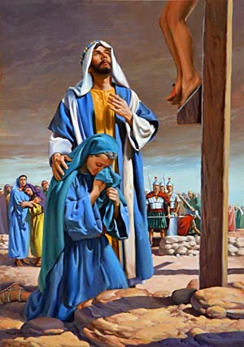
Chelmsford Catholic Collaborative
Confirmation Program
MASS REFLECTION

Parish (circle one): St. John’s or St. Mary’s Year (circle one): Confirm I or Confirm II
Name: ____________________ Table:_____________________

LITURGY OF THE WORD
1st Reading, Responsorial Psalm, and 2nd Reading: What is one thing that you remember from any of these readings/songs? Can you see it applying to anything in your life?
_________________________________________________________________________________________________________________________________________________________________________________

Gospel: What was said or done during the Gospel? How did people respond to this? How do you think you would have responded if you were there? How might you respond today?
_________________________________________________________________________________________________________________________________________________________________________________

Homily: What from the homily stuck out to you? What were you able to relate to or find advice from in the homily?
_________________________________________________________________________________________________________________________________________________________________________________

LITRUGY OF THE EUCHARIST
During the Eucharistic Prayer, we give thank and praise to God, what are you grateful for this week? We also ask God for the grace we need, what might you need help from God for in your life?
____________________________________________________________________________________________________________________________________________________________________________

